Mathematics: Units 2C and 2D
Formula Sheet

Number and algebra

Index laws: 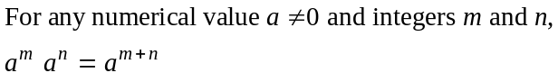
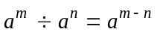

Space and measurement

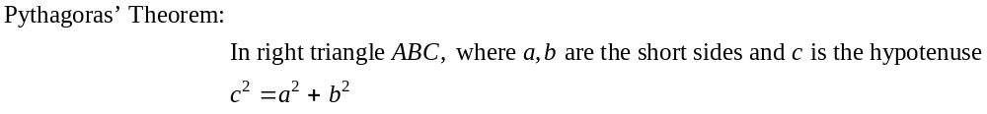
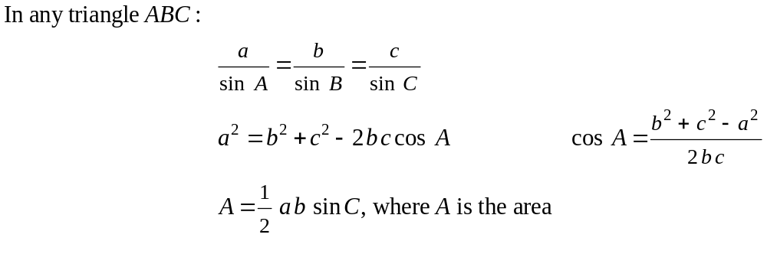
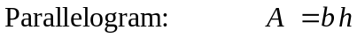
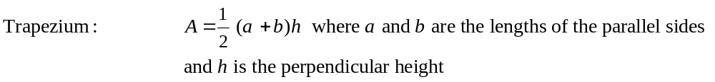
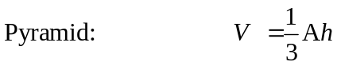
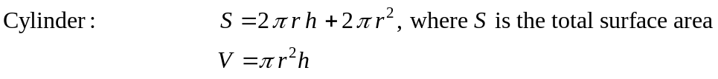
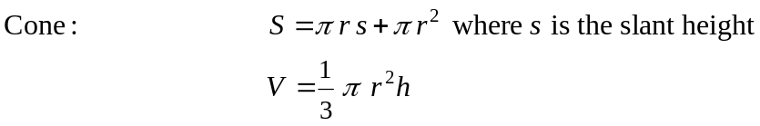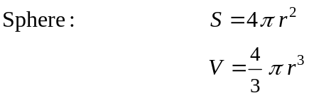

Space and measurement

Chance and Data

Note: Any additional formulas identified by the examination panel as necessary will be included in the body of the particular question.

